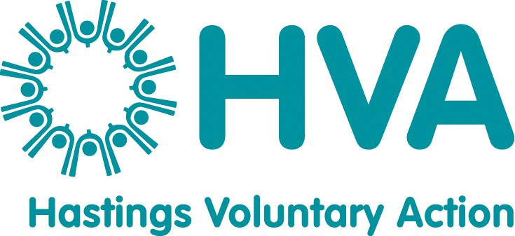

JOB DESCRIPTION

Job Title: Age-friendly Volunteering Project Worker x 2
(ref: HVA19A & HVA19B)
Responsible to: Peter Thorpe, Deputy Director of HVA
Location: Jackson Hall, Portland Place, Hastings, TN34 1QN
Hours: 18.5 hours per week (n.b. A full time working week at HVA is 37 hrs)
Salary: NJC new scale point 23 (from 1 April 2019, £26,999 for a full time role).
Duration: Fixed term until 31 March 2020, with a possible extension.
Holidays: 27 days plus Bank holidays pro rata
Pensions: HVA will match contributions of up to 7% of annual salary towards a mutually agreed pension scheme.

OVERALL PURPOSE OF JOB
Hastings Voluntary Action will employ two Age-friendly Volunteering Project Workers, who will pilot specific projects to support older people into volunteering and continuing volunteering. The Project Workers will also capture the learning from these pilot projects, reflect on the findings, and create reports and tools to share our learning with others across the country. These two roles will be supported primarily by HVA’s Deputy Director and external consultants, and liaise with HVA’s Group Support Worker.

Main duties

- Recruit, train and support older people to act as Volunteer Champions, and help them to share their volunteering stories to inspire other people to volunteer.

- Create a supportive group for older people who are not currently volunteering, help them to overcome any barriers that they may face, and support them into volunteering when they are ready.

- Review how specific organisations recruit and retain volunteers, and advise those organisations how they can make their policies and practise more age-friendly and inclusive.

- Create publicity to progress the project’s activities, which could include banners, leaflets, posters, and articles in HVA’s newsletter, website and social media.

- Collate information about local volunteering opportunities and publicise this information in various forms.

- Organise volunteering celebration events and volunteer recruitment events.

- Capture the learning from the project’s activities, in various forms including feedback from participants, quotes, case studies, observations, photos and video.

- With others, evaluate the success of the project’s activities.

- Record the project’s activities in written form, and present the model to others so that they can create something similar.

General duties

- To work collaboratively as part of HVA’s staff team towards the aims and objectives of the organisation as a whole and assist with general office duties (answering the telephone, dealing with personal callers) in the absence of other members of staff.

- To provide written work reports and participate in HVA meetings as required e.g. team meetings, supervision sessions, review days and management committee meetings.

- To comply with HVA’s operational policies, procedures and guidelines.
- To assist HVA with the implementation of its equalities policy by ensuring that a general equalities duty is upheld together with specific attention focused on parts of the community which experience disadvantage or discrimination.

- Keep up to date with relevant legislation, policies and practices, including undertaking research and attending appropriate training opportunities.

- To undertake any other duties as required which are in line with the post.
___________________________________________________________________
Whilst every effort has been made to outline all the main duties and responsibilities of the post, a document such as this does not permit every item to be specified in detail. Also, the post holder may, from time to time, be asked to undertake other reasonable duties commensurate with the grading of the post.

March 2019

PERSON SPECIFICATION

JOB TITLE: Age-friendly Volunteering Project Worker

You will need to demonstrate on the job application form and in the interview that you have the following experience, skills and attitudes.

EXPERIENCE
Essential
- At least 2 years’ experience of recruiting and supporting volunteers AND/OR at least 2 years’ experience of supporting older people to reach their potential.
- Significant experience of evaluating work and recording the outcomes.

Desirable
- Experience of training people in a group setting.
- Experience of organising and running events.
- Experience of organising meetings or events and associated administration.

SKILLS

Essential

Excellent communications skills (in person, on the telephone and in writing) and ability to explain complex information in simple language.

Good IT skills, including Word, Excel, databases, emails, presentation software and social media.
- Excellent observational and analytical skills.

Ability to create written documents of a high standard with attention to detail.

Excellent customer service skills.

Good organisational skills and ability to plan and prioritise a complex workload to meet deadlines.
Desirable
- Ability to create good quality videos and edit them

ATTITUDES
Essential
- A flexible approach to work and a willingness to learn.
- Ability to use initiative and be self-motivated, within a structured workplan.
- Ability to work as part of a team.
- Ability to work with a diverse range of people, some of whom need extra support
- A friendly, positive and non-judgmental attitude to people.
- Ability to work under pressure and maintain a positive attitude to work.
- Awareness of professional boundaries and confidentiality.
- Tact, diplomacy, and assertiveness where appropriate.

OTHER REQUIREMENTS
- Willingness to travel in the Hastings area and occasionally across East Sussex.
- Occasional travel to attend workshops in London or elsewhere in England, with possible overnight stay.
- Occasional evening and weekend work may be required.
- Willingness to undertake further relevant learning and professional development.
March 2019

