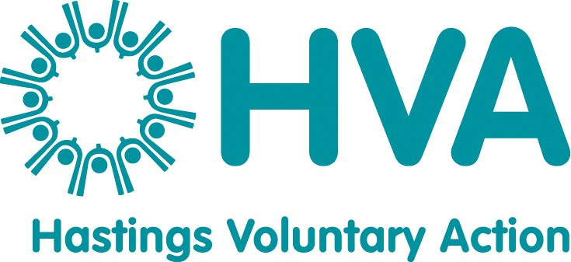

JOB DESCRIPTION

Job Title: Group Support Worker (ref: HVA19C)
Responsible to: Peter Thorpe, Deputy Director of HVA
Location: Jackson Hall, Portland Place, Hastings, TN34 1QN
Hours: 18.5 hours per week (n.b. A full time working week at HVA is 37 hrs)
Salary: NJC new scale point 23 (from 1 April 2019, £26,999 for a full time role). Rising to NJC new scale point 25 depending on performance.
Duration: Permanent (subject to funding and performance).
Holidays: 27 days plus Bank holidays pro rata
Pensions: HVA will match contributions of up to 7% of annual salary towards a mutually agreed pension scheme.

OVERALL PURPOSE OF JOB
The Group Support Worker will support charities, community groups and social enterprises in Hastings to start, grow and thrive. This will include providing information, advice and support around all aspects of running an organisation, including funding advice, governance, policies, volunteering and training. This role will be supported primarily by HVA’s Deputy Director and HVA’s Community Accountancy & Group Support Worker.

Main duties

- Support local residents to create new community groups, charities and social enterprises, and advise them about appropriate legal structures, sources of funding and help them to create or revise their governing documents.

- Enable local voluntary and community organisations to run more effectively, including helping them to create appropriate policies and procedures.

- Develop HVA’s Volunteering Service, including volunteer brokerage for people who want to volunteer, advice and guidance for volunteer involving organisations about volunteering matters, organise Volunteer Co-ordinator Networking Forums and other events, and liaise with East Sussex partners.

- Promote good practise and publicise new legislation relating to voluntary and community groups, directly to organisations and through HVA’s newsletter, website and social media.

- Participate in relevant community events to promote HVA and the services that we offer.

- Ensure that records on use of the service are maintained and to develop and implement appropriate methods of evaluation.

- Take opportunities to earn income in line with HVA’s approach, and seek continuation funding for this role.

- Be flexible to adapt and take on different tasks and responsibilities as HVA evolves and gains new pieces of work.

General duties

- To work collaboratively as part of HVA’s staff team towards the aims and objectives of the organisation as a whole and assist with general office duties (answering the telephone, dealing with personal callers) in the absence of other members of staff.

- To provide written work reports and participate in HVA meetings as required e.g. team meetings, supervision sessions, review days and management committee meetings.

- To comply with HVA’s operational policies, procedures and guidelines.
- To assist HVA with the implementation of its equalities policy by ensuring that a general equalities duty is upheld together with specific attention focused on parts of the community which experience disadvantage or discrimination.

- Keep up to date with relevant legislation, policies and practices, including undertaking research and attending appropriate training opportunities.

- To undertake any other duties as required which are in line with the post.
___________________________________________________________________
Whilst every effort has been made to outline all the main duties and responsibilities of the post, a document such as this does not permit every item to be specified in detail. Also, the post holder may, from time to time, be asked to undertake other reasonable duties commensurate with the grading of the post.

March 2019

PERSON SPECIFICATION

JOB TITLE: Group Support Worker

You will need to demonstrate on the job application form and in the interview that you have the following experience, skills and attitudes.

EXPERIENCE
Essential
- At least 2 years’ experience of working or volunteering in charities, community groups or social enterprises, or supporting/advising such organisations.

Desirable
- Experience of advising people about different voluntary sector legal structures.
- Experience of advising voluntary and community organisations about funding.
- Experience of completing funding applications.
- Experience of recruiting, supporting and supervising volunteers.
- Experience of training people in a group setting.
- Experience of organising and running events.
- Experience of organising meetings or events and associated administration.
- A relevant qualification in community development or training or similar.

SKILLS

Essential

Excellent communications skills (in person, on the telephone and in writing) and ability to explain complex information in simple language.

Good IT skills, including Word, Excel, databases, emails, presentation software and social media.

Ability to create written documents of a high standard with attention to detail.

Good customer service skills.

Good organisational skills and ability to plan and prioritise a complex workload to meet deadlines.

ATTITUDES
Essential
- A flexible approach to work and a willingness to learn.
- Ability to use initiative and be self-motivated, within a structured workplan.
- Ability to work as part of a team.
- Ability to work with a diverse range of people, some of whom need extra support
- A friendly, polite and non-judgmental attitude to people.
- Ability to work under pressure and maintain a positive attitude to work.
- Awareness of professional boundaries and confidentiality.
- Tact, diplomacy, and assertiveness where appropriate.

OTHER REQUIREMENTS
- Willingness to travel in the Hastings area and occasionally across East Sussex.
- Occasional evening and weekend work may be required
- Willingness to undertake further relevant learning and professional development.
March 2019

