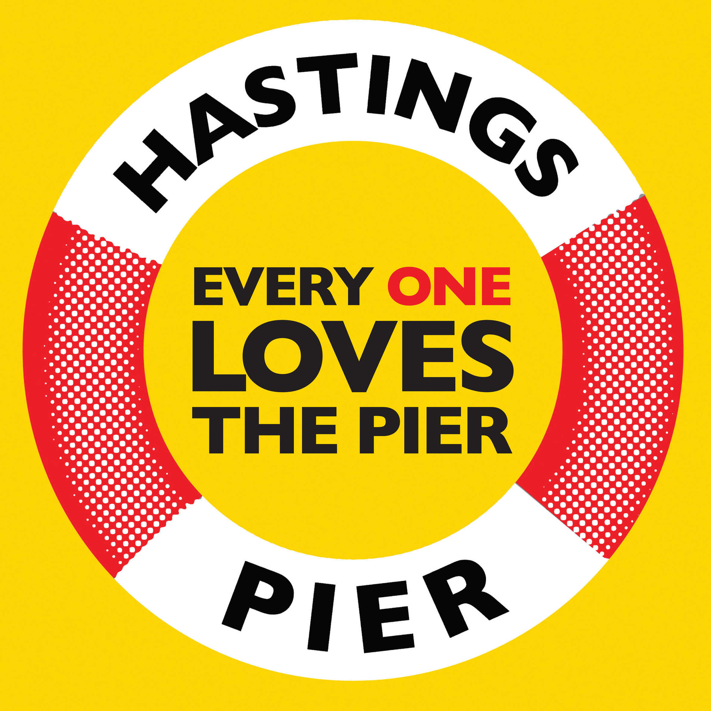
FRIENDS OF HASTINGS PIER

BUSINESS PLAN UPDATE – 11 June 2018

In the Friends Plan for Hastings Pier that we submitted on 12th April we asked for 6 months to find or create a commercial operator partner. We were told that was not possible. Two months on we have a commercial operator partner/investor in place ready to
- install and operate a new income-generating temporary structure immediately and at their own cost
- work with Friends of Hastings Pier to agree the balance of commercial operations and community commitments

Since 26th April our Crowdfunder has raised £426,000 from over 1500 individual donors. We need to close the gap to £500k and are in discussion with potential larger donors while continuing to encourage the smaller donors who show how widely the pier is loved.

With the assumptions we have used, which are laid out in the Financial Model, these two strands result in losses of less than £100k this financial year, breakeven in Year 2, and surplus in Year 3. Alongside this crowd-funded cash, we have sufficient offers to help support cashflow and underwrite the losses anticipated in the revised plan.

Our updated Transition Plan is broadly:
- income streams as laid out in the previous plans submitted in May (existing F&B facilities, shop, hire of climbing wall, club house, music events/festivals/cinema).
- plus net revenue from the new temporary structure going direct to the bottom line to support the pier’s costs.

During that time we will be raising funds for the permanent new building which we hope to open for the 2021 season. Our expert fundraiser has said:
“As you will see from the results of the comprehensive funding search, there are limitations to how much is possible at this stage, and until the administrators have made their decision.
That said, if the Friends were to be successful with their bid to take the Pier forward, there are a plethora of potential funders that could help you realise your Phase 2 Plans and raise the necessary capital funds to reconfigure the pier.
In my professional opinion, as someone who is a Full Member of the Institute of Fundraising, a former Director of Fundraising with a number a charities, and who has been working as a fundraising consultant for the last 5 years, I believe it is absolutely possible for the Friends to raise the funds needed for Phase 2, and bring a network of funders together to make this happen. You are certainly considerably better placed than a commercial operator to do this.
There is no denying that this will be a challenge, but the history of the pier is that it has often achieved what initially looked difficult, if not impossible, and it is certainly less challenging than it was to resurrect the pier after the last fire.”

