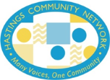
Supported by:
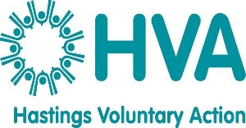

Hastings Community Network (HCN)
Terms of Reference
HCN is an over-arching network comprising of local voluntary community and faith groups, networks and forums.
It offers communication channels between the voluntary and community sector and those who make decisions locally.
We identify ways in which members can participate and influence decisions affecting the delivery of services.
We aim to ensure that representation of VCS views is conducted in an effective transparent and effective way
HCN links with Hastings Borough Council, East Sussex County Council, local NHS structures and is a member of the Local Strategic Partnership.
HCN brings together representatives from the voluntary and community not-for-profit sector in Hastings to identify areas of common interest and share information.
IN response to members’ needs HCN run regular themed events are held that focus on key current issues.
Networking opportunities are also organised to encourage joint working and collaboration.
HCN elect an Executive Board of community and voluntary sector representatives who drive the work of HCN forward.

