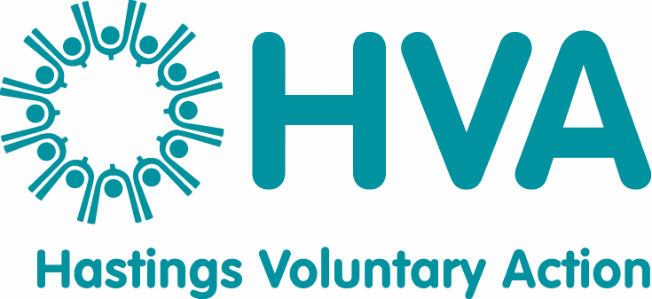

Become a Trustee of Hastings Voluntary Action!

Would you like to govern and steer Hastings Voluntary Action and help it to provide better services for the local community? Hastings Voluntary Action is looking for people with time to spare to serve as a trustee for the forthcoming year. The Board is keen to ensure a strong balance in terms of age, gender, ethnicity, disability and size of organisation, and encourage all members to consider becoming a part of our management structure. If you can bring dynamic management, HR, fundraising, or marketing into the mix, we would really like to hear from you!

HVA is a charitable company, and so elected members are trustees of the charity and company directors, with the liability of elected members being £1. The Board meets around 6 times a year with meetings held at HVA’s premises in Hastings. In addition trustees could be invited to join working groups which reflect their particular area of skill or interest. HVA can reimburse any out of pocket expenses.

Board meetings currently take place on Wednesday mornings at HVA’s offices from 10am to 12noon. We will organise an induction session for newly elected trustees.

HVA’s current board comprises the following (as of October 2023):
Sue Adey, One Voice Foundation
Helen Barraclough, ETC Sussex
Mary Carter, Adfam
Dr. Nell Chang, Hastings Chinese Association
James Johnson, Friends of Africa and the Caribbean in England (FACE)

Every year, a third of our trustees are required to stand down, but are eligible to stand for re-election. Our rules allow for up to ten trustees to be elected that represent member organisations, and to co-opt up to three independent people. HVA is now seeking nominations to fill these positions.

Nominations: Each organisation that is a member of HVA can nominate a representative to stand for election to join HVA’s trustees. If you are unsure whether your organisation is a member of HVA you can check by contacting Matt Pitts at HVA at matt@hastingsvoluntaryaction.org.uk or 01424 444010.

If you would like to stand, or to nominate someone from your organisation, then please complete the enclosed nomination form. If there are more nominations than there are places available, then voting will take place by secret ballot at the AGM.

Nominations for the trustee vacancies must reach HVA in writing by 5pm on Tuesday 14 November 2023. If you would like to discuss the role of trustee at HVA or would like further information, please contact Peter Thorpe on 01424 444010 or email peter@hastingsvoluntaryaction.org.uk

Nomination Form to be a trustee of Hastings Voluntary Action 2023

Please return to: HVA by 5pm on Tuesday 14 November 2023 by email to peter@hastingsvoluntaryaction.org.uk or by post to HVA, Jackson Hall, Portland Place, Hastings, TN34 1QN, marking the envelope or email with “TRUSTEE NOMINATION”.

Section A - Nominee

□ I am nominated by a current HVA member organisation and I want to stand for election as a Trustee/Director of Hastings Voluntary Action at the Annual General Meeting on Friday 17 November 2023. (complete sections A,B&C)
OR □ I want the trustees of Hastings Voluntary Action to consider co-opting me to their Board as an Independent person (at their next meeting in February 2024) (complete sections A&C)

Your Full Name
Organisation
(if any)
Your Home Address:
Your Email:
Telephone: |  |  | Date:

Section B – Proposer (if applicable)

My organisation wishes to nominate the person above for election as a Trustee of the Hastings Voluntary Action at the Annual General Meeting on Friday 17 November 2023.
I confirm that my organisation is a current member of Hastings Voluntary Action.

Name of Proposer
Organisation
Role / Position
Email:
Telephone: |  | Date:

(continued …)

Section C - Nominee

To comply with Charity Commission requirements, could you please answer the following questions:
- Are you 18 or over? Yes/No
- Are you resident in the UK? Yes/No
- Have you even been convicted of a criminal offence involving fraud or dishonesty? Yes/No
- Have you ever been removed by the Charity Commissioners from office as a charity trustee? Yes/No
- Have you been subject to a disqualification order under the Company Directors Act 2006 or the Insolvency Act 2006? Yes/No

Please include below (or on a separate sheet), a brief description of the skills, knowledge and experience you would bring to the work of Hastings Voluntary Action (200 words max). This information may be circulated to people attending HVA’s AGM, and used in the event of an election, and published so that people can learn more about HVA’s trustees.

