A WAY TO RECOVERY IN HASTINGS
This document travels upon “After the First Wave” published on the HVA website in June 2020. It should be read in conjunction with it and other input from the Third Sector located there. It is intended as a constructive contribution to developing the future.
- According to the Joseph Rowntree Foundation (JRF) the 20 English local authorities with the highest proportion of England’s most deprived neighbourhoods are all found in Birmingham northwards with one exception, Hastings.

- Areas of the economy where Hastings is strong have high rates of poverty:
  - Hospitality sector and cultural activity
  - Retail
  - Residential care
These are not areas easily adapted for working from home or working safely.

- JRF estimated that the biggest numbers of those living in poverty live in England’s inner cities. However, higher proportions of people in poverty may live in in coastal and ex industrial towns. The visitor economy is very dependent on London and the confidence of London consumers. Characteristic of Hastings (and East Sussex) shares with many coastal towns is the importance of micro and small businesses. This may be a cause of initial weakness in the face of recession.

- In seeking resources for recovery, the South East will not be perceived as a priority. Inner London will be because of BAME communities and poverty caused by high housing costs. London’s economy will be impacted but is highly resilient and may well recover fastest.

- Hastings is already recognised through the Town Deal and Opportunity Area as having deep rooted issues. The make up of our economy does not lead to optimism about fast recovery.

- Whilst Hastings Borough Council awaits news about the generosity of government’s additional support to local government it is unlikely to easily recover a gap of almost £4m identified in the report of the Chief Finance Officer to Cabinet. Although it is too early to speak with certainty on questions of detail it does seem that the council must face reductions in staffing and capacity that may bring it closer to a future of focusing on statutory services and those funded through special programmes like Town Deal. Upper tier local authorities like County Councils are also hard pressed and although adopting a strategic focus upon regional transport and economic development they face the same issues of relevance as the Districts/Boroughs. In this case the massive nature of the care/heath agenda and the reduction of educational responsibility point to a short-term need for more funding and both tiers potential obsolescence. This doesn’t mean local government is finished but may now be re-shaped by the forces let loose by the pandemic in ways and previously not considered or at greater speed. The current focus on capital projects/funding is a significant challenge – Hastings is unlikely to have an easy to deliver capital projects that yield significant complimentary action to deliver people into economic activity/inclusion. Employment creation/skills in the short term is likely to be revenue intense and needs to be firmly linked to national and local capital programmes.

- The individual partners in the 3rd sector, health, local government, police and colleges have been productivity forced into much faster ways of working and of mutual appreciation. The effectiveness of hub working is apparent. The main risk is that we all slip back into old rigid patterns of work and do not continue to accelerate the pace of working:
  - As being required as the virus bumps along or increases rapidly to sustain community support in both circumstances. Devising new responses to a second wave would be highly problematic
  - As offering potential to deliver new responses to the economic recession and mitigate its impact in partnership
  - Simply being potentially more cost effective as in an environment where money will be very short, targeted and probably even more politicised in its prioritisation.

- The government will announce its programme to support employment in the coming period and has given priority within this to action that will focus on young people. In all sorts of ways it is retraining young people in the economy and motivating them for the future which is critical both to them and the wider UK.
  - £2,000 for each new apprentice under 25. This is in addition to the £1,000 available for 16-18 year old apprentices and those under 25 with an education, health and care plan.
  - Tripling the number of traineeships aimed at young people.
  - New sector-based academy placements, doubling the number of work coaches and 250,000 more young people to benefit from the careers service

- There are other features that should be of interest to us:
  - £88 billion to make 140,000 green jobs and improve buildings
  - £2 billion green bonus grant and a £1 billion scheme to improve public buildings and facilities
  - Support for shovel ready jobs
It is important to learn more about what is now and what be the representation of existing capital programmes.
- The support to the hospitality sector of reducing VAT and the Eat Out to Help Out scheme may be of assistance. The removal of stamp duty on property is of proportionately more advantage to transactions on properties of higher prices and is something we should approach the property sector on for their views.

- It appears unlikely that significant rail improvements to Hastings (or improvements to the A21) will now be delivered in a timescale that will have any impact on business investment or attract new residents
  - It is uncertain how future travel patterns and demand will evolve
  - In the context of other infrastructure demands inside the UK improving one of three rail connections between Hastings and London may appear to be economically and environmentally low yield at considerable cost
  - Road improvements of the future may be most modest with increased emphasis on modal shifts within urban areas
Our planning needs to be for a medium-term future without substantial improvements in physical connectivity. However, this might be less significant than it appeared 6 months ago. If there is a sustained reduction in commuting to work (people either stopping or doing it on less days) some of our relative competitive disadvantage may change.
- Conversely our very large population of relatively disadvantaged may be further hit. Hastings has high proportions of hospitality and retail jobs requiring relatively low skills and paying lower wages. These jobs may not recover easily. They also depend upon a high quality product and environment that people will want to visit and feel safe in. To give two examples:
- Many pubs in the Old Town (but less elsewhere) do not have extensive outdoor space and have traditionally been crowded, noisy and feature live music and entertainment. Their capacity is likely to be reduced considerably and the confidence of many consumers difficult to revive
- Our physical fabric requires investment if more buildings become redundant challenges may become clear. But the public realm is also critical. The costs of investment are high as illustrated by the creation of the Source Park in the old bathing baths/ice rink and the current mammoth work on the Observer building. These are model which do not easily give standard investment returns.
- In order to mitigate further the impact on young people, low skilled, those with health issues and low paid women in particular it is likely we will need to consider how employment opportunities connected to skills training can be further generated.

- The County recovery plan contains some links to things partners wished to do but it was agreed that a Hastings plan was required which view a whole range of strategies approaches as contributing to a local programme – and enabling Hastings to be seen as contributing to wider recovery.

- We have not paid sufficient attention to health and in particular the critical nature of dealing with the mental and physical health impacts of a prolonged downturn and/or a second wave of the virus. These pressures will be imposed on already very high levels of ill health. Hastings responded with enormous energy to the beginning of the Covid19 crisis but will need a more sustainable response going forward. It is critical to see the heath/economic/inclusion agendas as co-joined to be both effective but not to waste time with approaches that are not integrated. There should be space for innovation here.

Potential Response

- Hastings has the real advantage of a structure which provides
  - A functioning LSP supported by an Executive Delivery Group
  - A Town Deal Board which contains many of the same members of the LSP
  - A range of live programmes like CHART and Opportunity Areas
  - Strong input in particular from CCG
  - The opportunity for renewed relationships between FE/HE and other partners
  - A Hub recognised as being effective in co-ordinating statutory and voluntary effort over the crisis
  - A history (still existing in the local memory) of managing and administering substantial regeneration programmes
  - A network of partnership structures which are effective but increasingly operating outside borough boundaries – police/community safety, CCG/health, Hastings & Rother Economic Task Force, SELEP coastal group, Team East Sussex, East Sussex cultural partnership, 1066 Country
  - Strong voluntary sector – new organisations like HEART emerging
  - A regeneration company (Sea Change Sussex) which owns significant assets in the town and the wider area can help establish a reputation for effective project delivery.

- In the current context a coherent response to recovery post Covid19 cannot depend on restoring the past. Firstly, it’s not achievable and a crisis ought to be the vehicle for thinking about something better. But it’s going to be complicated and requires a degree of co-ordination not seen before particularly in the absence of lubricating external funding streams like the previous neighbourhood renewal programme. We must work to scope the principles for moving forward now.

- Hastings sometimes appears to its partners to speak with discordant voices and to resist pressure for efficiency in favour of accommodating differing views, competing personalities or ideologies. This is a difficult one to balance as diversity can bring its own rewards. But scarce resources will require greater commitment to efficient organisation. For example a joined up view of support to the community ranging over food, personal support and family support would be an enormous strength but require common systems and shared leadership.

- Clearly about intended outcomes and greater boldness in identifying them will also be beneficial. For whom will life be better and why as we work together. We should not forget how widely relative poverty and exclusion is distributed in Hastings or the scale of action required to address it. But for many people economic independence and adequate housing represents the principle means to a sustainable life. A lot of what we need to provide is pretty basic but needs to be replicated many times. This is particularly true of housing, job creation and uplifting skills. Our low values distance from market and low skill economy mitigate against rapid job and housing growth.

- Set against this are all the positives including the creative energy of so many people and a widespread recognition that things have dramatically improved over the last 15 years. We still haven’t found a “big” USP – the University was one, Channel 4 could have been another and culture provided a potential answer. The forthcoming borough plan and Town Deal bid offer the opportunity to regroup around a renewed shared vision.

- Below is a diagram that sets out in crude terms how this might work.

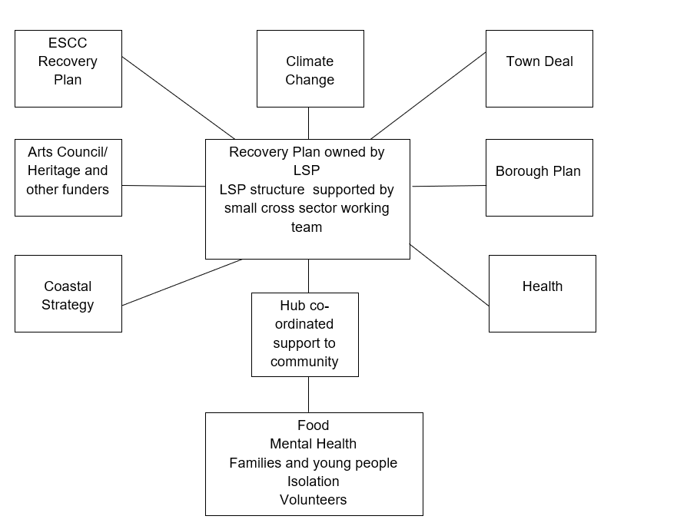
Hastings & Rother Economic Task Force

- This would need to be supported by a team of people who are committed by their organisation to support the creation and delivery of a Hastings plan. It is envisaged that this would chiefly be drawn from input of time from partners. Clearly Hastings Borough Council, Clinical Commissioning Group and East Sussex County Council are critical to these processes, but other partners like cultural and environmental partners are likely to have a significant role as well as those playing a leading role in education and the third sector. Hastings Voluntary Action (HVA) is prepared to contribute resources to the work of such a team.

- However, HVA’s views is that the core of the support structure would need the investment of new time
  - To work on the creation of a coherent local programme
  - To develop relationships with partners and provide overview of progress and a shared view of the future
  - To grow relationships with external partners and government and support a “cross thematic” approach with all of them
  - Development of a range of key outcomes and outputs which would guide the priorities of partners and provide a framework for judgement of progress
  - Engaging with academic partner(s) to have future regeneration work impartially assessed and usefully interpreted
  - To support the development of new patterns of delivery reflecting technology, changes wrought by Covid19 and reduced or changed capacities. It’s likely that the priorities of organisations will change as government policy and economic circumstances unfold
  - Review the network of partnerships in terms of future effectiveness
  - To put together a town wide plan to maximise ability to delver hospitality and cultural activity particularly through outdoor performance and catering on areas like The Stade
  - Consider how tourism/traffic will be managed until a vaccine can re-instill confidence in public transport
  - There has been much innovative work begun around virtual culture. Can this create employment or business
  - A town that cares – about its visitors and its residents health in putting together and publicising its programmes
  - Public realm interventions using employment scheme funding. This is both long and short term if property values will not drive the delivery of plans like Bohemia or the town centre there are other ways to enhance the investability and attractiveness of the town.
  - As a first step develop a co-ordinated approach to unemployment, continuing support to the vulnerable in the short (but very urgent) term including the government’s retrofitting programme. It is suggested that a priority action is calling together partners to develop a robust local response.

- If partners are supportive of this approach HVA suggest that a business case is put together to develop this model of working in partnership with Hastings Borough Council, CCG, College and business partners. This should be done over the Summer given how rapid the rise in unemployment may be.

