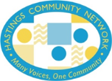
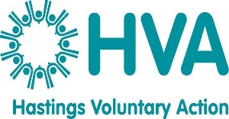
Supported by:

Hastings Community Network (HCN)
Voluntary Sector Representation – Code of Conduct

The code of conduct is intended as guidance: Any queries should be addressed to Hastings Voluntary Action by emailing: steve@hastingsvoluntaryaction.org.uk or by calling: 01424 444010

By virtue of the training provided, you are now a voluntary sector representative. As such, you will be representing the sector as distinct from representing your own organisation, often with external stakeholders, statutory partners or principal funders.

Key accountabilities:
- Strive to attend all meetings, sending apologies to the chair for necessary absences.
- If you are unable to attend meetings on a regular basis, please notify Hastings Voluntary Action or seek alternative representative support from other Executive members.
- Always prepare for any representation meeting by reading previous minutes and correspondence. Make sure you understand the agenda, and whether or not you will be required to speak or provide information.
- Talk to the meeting chair prior to the meeting if you require clarity or advice.
- Always arrive early to prepare, and always stay until the end of each meeting unless specifically excused.
- Always participate fully. You are representing seldom heard voices and your contribution needs to be vital and constructive: Never destructive: Listen to what others have to say, remain calm and always be concise.
- Help others concentrate on the meeting. Discourage side or tangent conversations.
- Have the best interests of the voluntary sector in mind at all times. Do not let personal opinion interfere with objective judgement.
- Identify and draw attention to any potential conflicts of interest that may arise during the meeting and declare them.
- Complete a meeting feedback report which should be returned to: Hastings Voluntary Action by email to: steve@hastingsvoluntaryaction.org.uk
- Fulfil any responsibilities assigned to you at the meeting and be prepared to report on your progress at subsequent Executive meetings.
- Be prepared to attend any best practice or network events about representation, which will help refine your knowledge and skill.

September 2020

