**Hastings Borough Council (HBC) Hastings Housing Strategy Workshop**

**Central Hall, Hastings**

**1st August 2025**

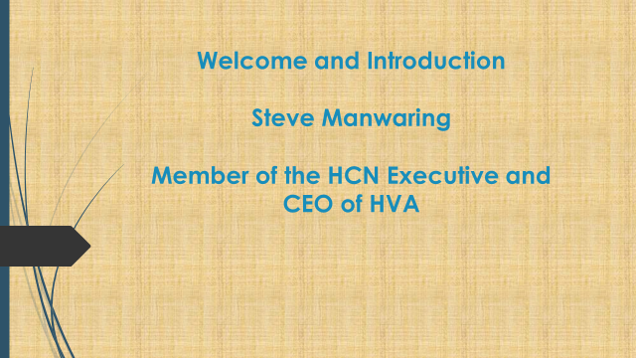

**Steve Manwaring opened the event, speaking about the functions of the HCN Executive (HCNE) Group:**

**To represent**

**To engage**

**To highlight and respond**

**To celebrate and promote**

**And how the HCNE engages with the community:**

**Six events per year**

**2 x themed events, 2 x open mic events, 1 joint HBC/HCN consultation event**

**All themed event topics chosen by membership using the ‘Hot Topics’ list**

**Brief pre-meeting before LSP if needed**

*Steve then introduced Alan Sheppard, the Housing Strategy and Operations Manager at Hastings Borough Council (HBC) who gave a presentation about the draft Housing Strategy:*

**The Five Priorities**

**Deliver the homes we need**

**Prevent homelessness and end rough sleeping**

**Create a rented sector which works for tenants and landlords**

**Homes that support health, independence, and longer lives**

**Reduce carbon emissions from housing and future-proof homes for a changing climate.**

*Mary Carter (HCNE) explained the interactive table activity with all attendees which asked them to use flip charts to record their views about the draft Housing Strategy*

|  |  |  |
| --- | --- | --- |
| **ATTENDEES** | | |
| **First Name** | **Last Name** | **Organisation** |
| Grace |  | Rebellion Housing |
| Lesley | Adaur | Mediation Plus |
| Teresa | Andrews | HARC |
| Penny | Beale | HHSS Group |
| Tricia | Burman |  |
| Jane | Caley | HVA |
| Mary | Carter | HVA/HCN |
| Michael | Courts | ESCC |
| Jane | Dye | FSN |
| Jodie | Goffee | Freedom Living Housing Co-operative |
| Mark | Goffee | Freedom Living Housing Co-operative |
| Graham | Hodgson | Care For the Carers (CFTC) |
| Kim | Kelly | HVA |
| Elise | Liversedge | Hastings Older Women Co Housing HOWCH |
| Steve | Manwaring | HVA |
| Gill | Reynolds | Sussex Community Development Association |
| Alan | Sheppard | HBC |

*Following the Table Activity, Michael Courts, Vice-Chair of Housing**Strategy Steering Group (ESCC) took a feedback and Q&A session*

**Deliver the Homes We Need**

* Homes with services and infrastructures
* Don’t need luxury, over-priced, badly built private flats
* Shared ownership is not affordable
* Planning permission should insist on genuinely affordable
* The Air B&B’s percentage of housing stock must be limited to a fair percentage
* Local government needs to be given the power to limit the number of planning applications
* Kit homes

**Prevent Homelessness and End Rough Sleeping**

* Homelessness prevention – learn from the Eastbourne Hub
* How will it be funded – will co-production and multi-agency partnerships be sufficiently funded? Include backfill etc for attendance, governance & leadership structures
* Neighbourhood level awareness workshops and dialogue to support refugees and migrants
* Prevent revolving door
* Funding – strategic leverage. Can’t rely on Trusts/Foundations to operate on a strategic level this longer term work requires
* Special support needs aligned with housing provision
* Pay heed to community tensions (especially new/refurbished accommodation, if better standard than settled social housing
* Address longer term impacts of long stays in temporary accommodation (TA) on physical/mental health, educational attainment, work prospects (when settled and when in TA)
* Prevention focus – financial to prevent eviction and address needs before home is lost.
* Local procurement
* Protecting the strategy through Devolution
* Where conflict is a factor in homelessness risk – provide access to mediation services, early intervention

**Create a Rented Sector Which Works for Tenants and Landlords**

* Affordability not keeping pace with income and now a two tier system
* Rent capping should be explored
* Short supply increasing rents
* Air B&B’s models elsewhere should be examined
* Homes not hotels
* Housing needs to be locally affordable
* Deposits and guarantees an issue (Bond Board)
* Anti-social behaviour or conflict – need for mediation
* Reform AST as the default tenure
* More support to co-ops, Hastings Commons; what can be learnt from this?
* Carers need to stop working. They face particular challenges
* How can people with long term health conditions keep their homes
* Kit homes and self builds
* More pressure to use vacant land to build on
* Make affordability linked to local wages and incomes
* Second homes taxed and money ring fenced for housing delivery
* Planning system needs to genuinely enable affordable housing and not let this be diluted
* Poor conditions; damp, guttering, condensation, difficult to heat
* Seaview developing HMO: look at this as a wider model
* Absence of ‘move on’ accommodation
* Temporary accommodation leading to isolation and limited opportunity to lead a normal life
* Proper approach to fuel poverty and energy

**Homes that Support Health, Independence and Longer Lives**

* Housing Associations (HA’s) – responsibility to promote social health
* HA residents to get more support to: meet and connect with each other, link in with local community activities and groups e.g. warm welcome space
* HA’s have spaces that are under used
* Support people to live independently in their own homes as long as possible to prevent them going into care homes
* Environment around homes is important, links to community safety & substance dependency, cleanliness
* Need long term security for tenants
* Improved understanding of loneliness and how it impacts health; Housing Strategy to link with ASC prevention work
* Create more community/living spaces
* Houses need to be in good repair e.g. insulated and with no mould/damp
* Street safety
* What assets are already out there? Housing/landscape
* Occupational Health to help people stay in their homes longer – should be a default
* Mediation support for neighbourhood conflict/ASB and in retirement schemes etc

**Reduce Carbon Emissions from Housing and Futureproof Homes for a Changing Climate**

* Car sharing schemes as part of housing development
* Housing based community transport (electric) for hospital visits etc
* Green roofs
* Solar/heat pumps need to be more affordable
* Incentivise the use of public transport away from car ownership
* More grants; profit over climate
* Stringent requirements on developers; climate over profit
* How does this fit with Conservation Zones
* Examples of quick wins you can easily implement
* Sharing financial incentives/realities/impacts of changes
* Water butts
* Budget and staff to maintain communal green spaces
* Heat loss drone surveys to highlight homes that have inadequate insulation
* Incentivise using car free electric/hybrid. Cycling
* Laws and strategy need to be enforced. Developers can’t move goalposts after getting contracts
* Best practice elsewhere (Europe)
* Need to be pollinator friendly
* Opportunity to bring together communities to share vision for climate concerns
* Climate change bus tours