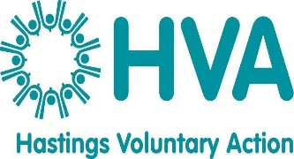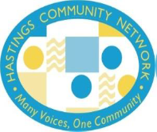

**HCN Arts & Cultural Communities Event with Marketplace**

**Central Hall**

**15th July 2025**

***Culture plays a vital role in building strong communities, fostering social inclusion and empowering residents. The cultural landscape of Hastings & St Leonards encompasses various organisations, events and initiatives that contribute to the area’s vibrant culture scene.***

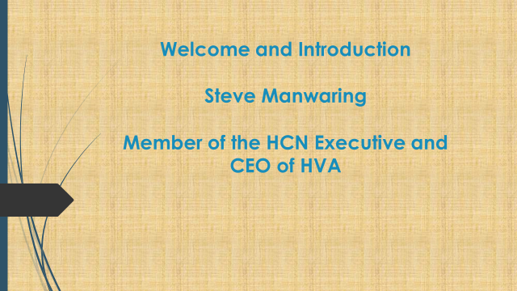

**Steve Manwaring welcomed everyone to the event and thanked them for attending.**

**He spoke about the functions of the HCN and how they engage with community organisations with events such as these and Open Mic sessions.**

**He also highlighted the Creativity for Healthier Lives Report written by the Director of Public Health in East Sussex; Darrell Gale.**

***Steve then introduced Mandy Curtis (Arts Hastings Chair/18 hours) who gave a presentation about the work of Arts Hastings.***



***Mandys presentation was followed by a break and a chance for attendees to network.***

|  |  |
| --- | --- |
| **ATTENDEES** | |
| **NAME** | **ORGANISATION** |
| **Julie Abson** | **SCDA** |
| **Sarah Alexander** | **Cabaret Mechanical Theatre** |
| **Su Barnicoat** | **HVA** |
| **Lorna Crabbe** | **Jack in the Green** |
| **Mandy Curtis** | **Arts Hastings/18 Hours** |
| **Joanne Davis** | **AOP** |
| **Sarah Dean** | **Southdown** |
| **Tracy Dighton** | **CAB1066** |
| **Teresa Flower** | **HVA** |
| **Renee Griffith** | **Independent** |
| **Julia Hilton** | **HBC** |
| **Zoe Jackson** | **EFT** |
| **Rowland Jobson** | **Seefood** |
| **David Jones** | **Pets as Therapy** |
| **NAME** | **ORGANISATION** |
| **Suzanne Klepere** | **ESCC** |
| **Fee Lock** | **Jack in the Green** |
| **Sophie Malpas** | **Cabaret Mechanical Theatre** |
| **Steve Manwaring** | **HVA** |
| **Merle** | **Explore the Arch** |
| **Joe Newland** | **Explore the Arch** |
| **Kiki Prince** | **Association of Carers** |
| **Gill Reynolds** | **SCDA** |
| **Polly Risbridger** | **The Bright Foundation** |
| **Garima Singh** | **Marianne North Centre** |
| **Jacqui Skilton** | **ESRA** |
| **Charlotte White** | **Change-Act!** |
| **Alexander Wilberforce** | **Marianne North Centre** |

***Following a lively networking session, Jacqui Skilton spoke about the work of ESRA and how it helps people in recovery. Some of ESRA’s clients wrote about how artistic activities have helped them:***

***‘Art and music are not only great tools for***

***communicating and expressing emotions,***

***they also bring about better concentration***

***and cognitive functioning’.*** **‘*Creative activities such as art, music,***

***and calligraphy gave me a focus to use***

***as a solid foundation at the beginning of***

***my recovery and also in maintaining my recovery’.***

***‘To be able to express my thoughts***

***and feelings through art and words***

***is great for my self-care and sharing ‘One begins to reintegrate with***

***with others in recovery is uplifting’. neglected parts of oneself and***

***develop a more positive sense of self,***

***which enhances healthy relationships***

***with others and an overall sense of***

***wellbeing’.***

***‘I found that just going out with my camera***

***and looking around for scenes I could frame***

***in the viewfinder gave me a new perspective***

***on the world as well as just getting me out and***

***about at all times of the year’.***

***Su Barnicoat (HVA) & Teresa Flower (HVA) facilitated an activity using a mapping tool to collect information about local community activities.***

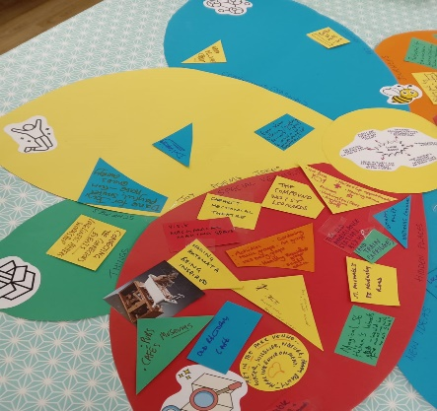 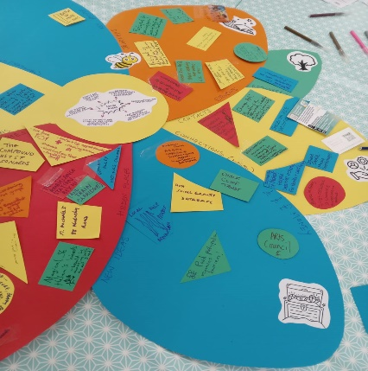

***Local Assets***

***The history, heritage & culture of a place***

***People and their gifts, skills, & talents***

***Informal community groups/networks and associations***

***Organisations & institutions***

***Land, buildings, transport, infrastucture & public spaces***

**Journeys & Stories**

* Participant to facilitators
* Participant to training social housing staff using theatre techniques
* Participant to directing a Forum Theatre Play about mens suicide prevention
* Mens Room, Hastings & St Leonards – men leading the way
* Mr Hastings & St Leonards – website, podcasts, Facebook, Men Don’t Talk film
* Dance Buddies – participants to volunteers
* Creative activities like art, music, calligraphy help people focus to use a solid foundation at the beginning of recovery from substance misuse
* At beginning of recovery develop natural abilities to create

**Local Contacts & Connections**

* Dance Hastings – Website, Facebook. Care homes, social dancing, inclusive
* Change, Act! – Theatre of the Oppressed, Legislative Theatre, community storytelling
* Blacklands Church – Pastoral care, inclusivity for people with special needs, isolation, art group, crafts group, toddlers & carers support, Warm Spaces & food support. Funding – collections and direct contributions
* Refugee Buddy Project
* Soundcastle – Music workshops
* St Michaels Hospice – Drumming, creative activity for health and wellbeing
* Babes in Arms, St Leonards – Artist collective for artists that are mothers
* Sussex VCSE Mental Health Network – Linked In, Facebook, Instagram
* Connecting the Connectors events, Loneliness Matters Workshops

**Special Venues & Hidden Places**

* Seaview – Hot food, housing advice, showers, washing facilities, nurse & GP appointments, supportive staff
* West St Leonards – The Compound, Cabaret Mechanical Theatre, visit the space
* Bexhill – The old ambulance station and train carriage
* Gotham Alley
* Hastings Commons
* Old Rectory Café
* The Humble Hub
* Art in the Park – Water, wildlife, nature, beauty, healing environment
* St Helens Woods – Would be amazing with an art shed

**Money**

* Chalk Cliff Trust
* Arts Council
* HVA Small Grants Database
* Paid participation removes barriers

**Joy**

* Dance for Joy, playful, smiles, noise, fun, chaos, energy
* Even when talking/exploring serious topics, humour and joy brings people together

**Resources & Key People**

* Makingithappen.org.uk – Resources
* Baton of Hope – Jacy Kilvert
* Warm Welcome charity

***There was an opportunity for further networking before Tracey Dighton (HCNE Co-Chair) closed the event, thanking everyone for their time and input.***

***As always, attendees welcomed the opportunity to share information with other local organisations in their field of work***

**Good format and convenient location, thank you.**

**The event has given insights into key decision making which will inform our planning.**

**It was a great informal yet informative event. As always, very well organised.**

**Met some great people from different organisations.**