 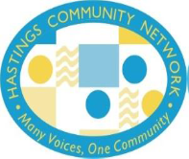

**Hastings Community Network Housing+ Event**

**22nd April 2022**

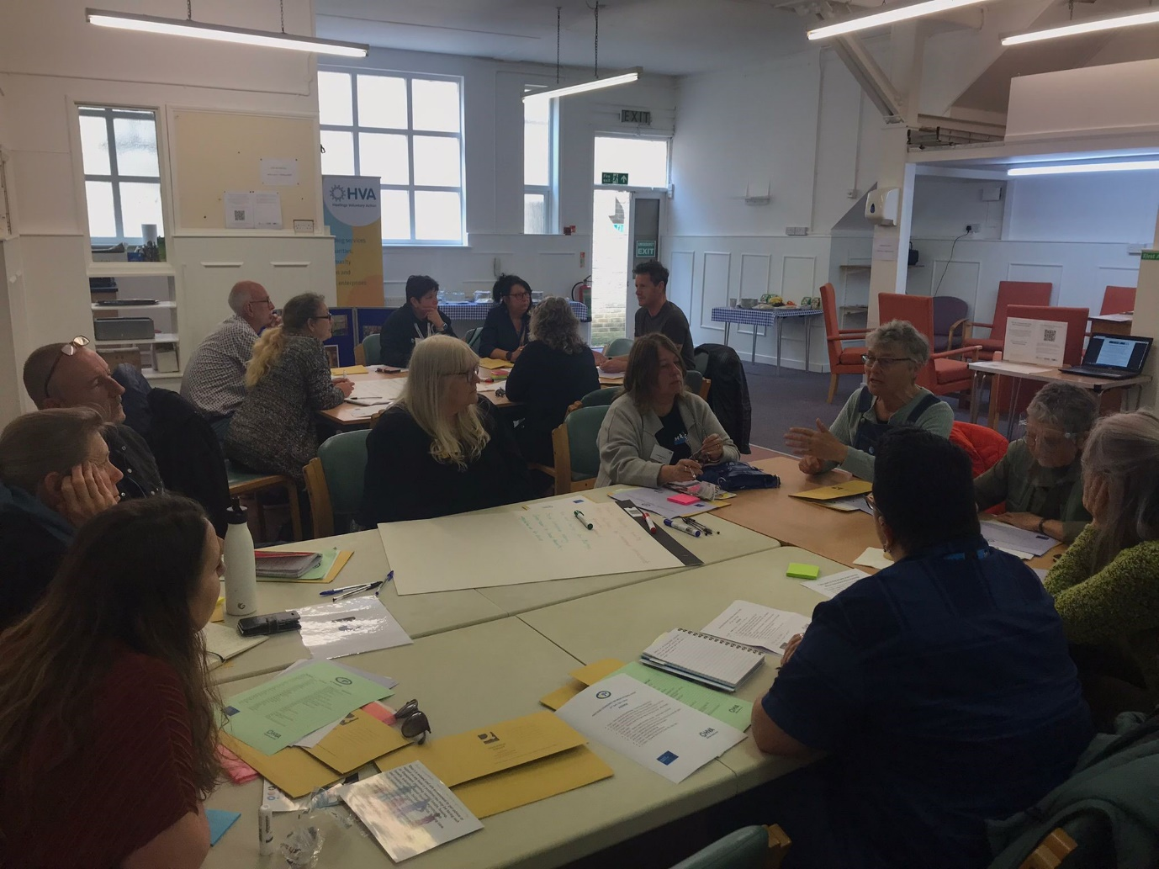

***Very useful, informative and well delivered event. Great to meet in person.***

***I’ve been pleased to attend and only hope we can collaborate to effectively change policy.***

**Introduction**

Hastings Community Network run regular events to bring together service providers, community organisations and policy makers so that needs are better understood and provision remains relevant and accessible. On this occasion HCN were pleased to collaborate with the Community Renewal Fund Knowledge Exchange Programme and are grateful for the financial support which enabled this event to take place.  With the current cost of living crisis, we believe that more and more people will become vulnerable in terms of the security of their housing situation.  By bringing 31 delegates from a range of backgrounds and services we were able to consider how we can improve provision and begin to construct a model which might reduce the barriers which sometime prevent those in need accessing the support they need.

**Carole Dixon (HCN Chair)** opened the event saying that this was the first ‘live event’ that we have been able to hold for over 2yrs and how good it was to see everyone ‘in the flesh’. Hastings Community Network managed to keep the cycle of events going online throughout the pandemic.

Carole encouraged people to complete the IVR survey about volunteering that was accessible on a laptop at the event.

Lastly Carole thanked the speakers and facilitators, the working groups and HVA colleagues for helping with the event.

**Tracey Rose (HCN Vice Chair)** spoke about how the theme for the event was chosen. Housing has become a big issue locally and nationally with rising rents and a decrease in affordable housing alongside the rise in house prices in Hastings. The aim of this event is to look at what we are doing as a sector and how we can support people to keep their homes in times of crisis.

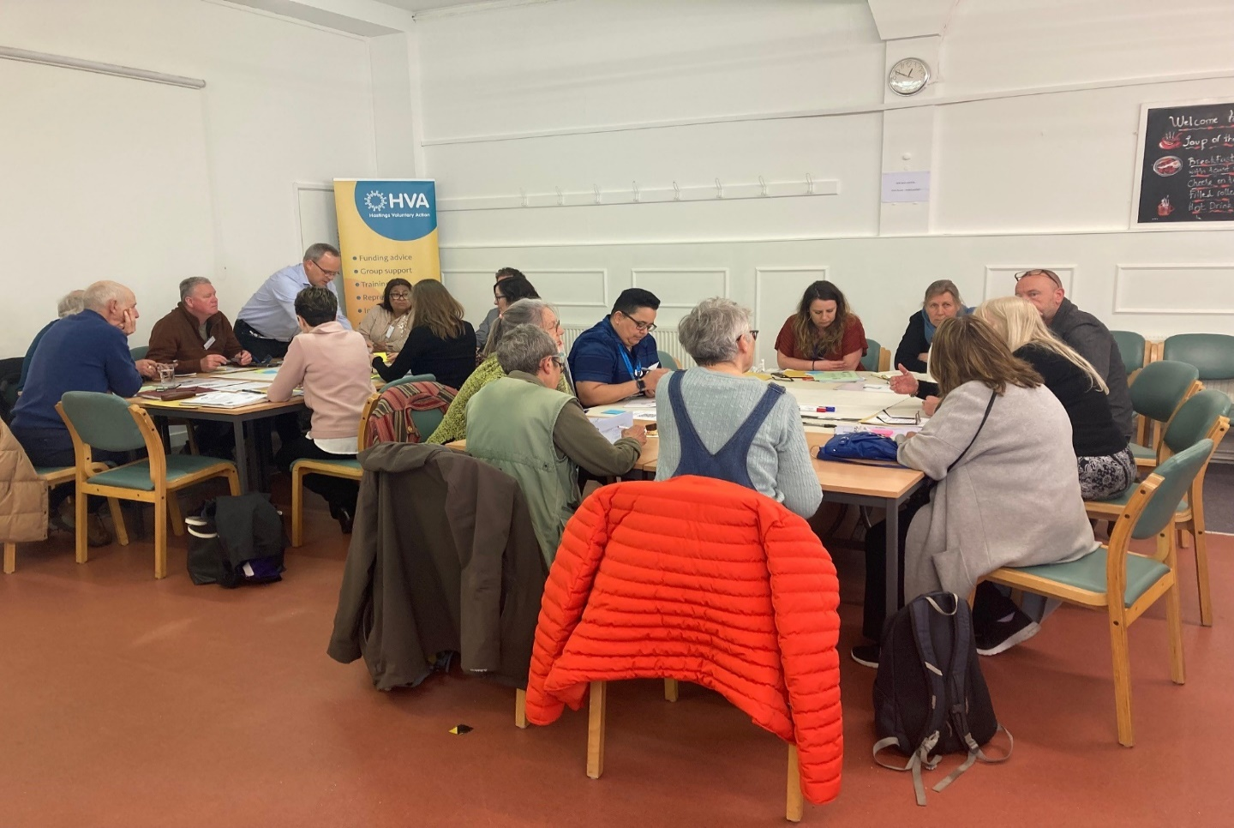

**Steve Manwaring (HVA Director) introduced the speakers:**

Mike Peplar from Citizens Advice 1066 who spoke about poverty and the stigma that people can feel about asking for help

Hollie Taylor from Seaview who spoke about hard to reach homeless people.

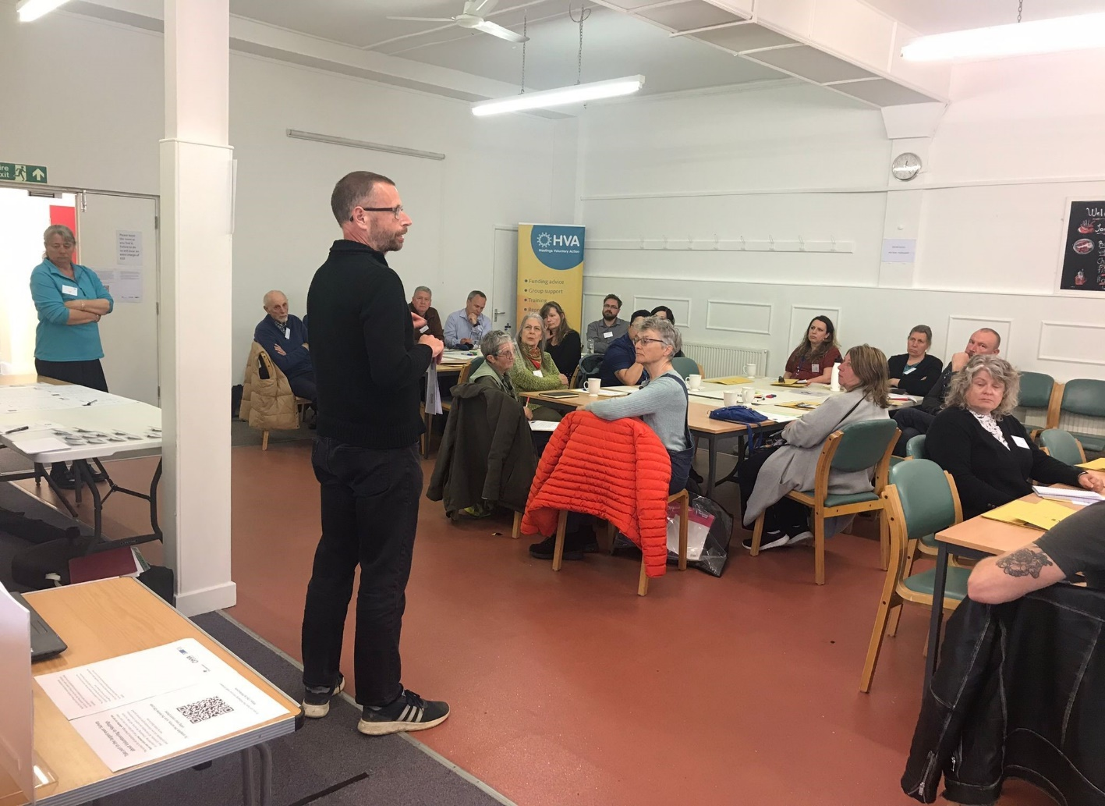

**Representatives from 16 local organisations attended the event**

|  |  |
| --- | --- |
| **Organisation** | **Organisation** |
| Hastings Borough Council | Transom Trust |
| Penny Beale Memorial Fund | YMCA |
| Education Futures Trust | HOWCH |
| Optivo | Parity Trust |
| Southdown | Seaview |
| Warming Up The Homeless | Citizens Advice 1066 |
| BHT Sussex | Fellowship of St Nicholas |
| Integrated Family Healthcare Ltd/PNC |  |

**Group Exercise**

The three tables in the room took part in group exercises with flip charts and Post Its to look at matching gaps and barriers in services with other services that can help.

**Table 1** facilitated by Mike Peplar from Citizens Advice 1066, looked at issues around support services for mental health, trauma and addiction.

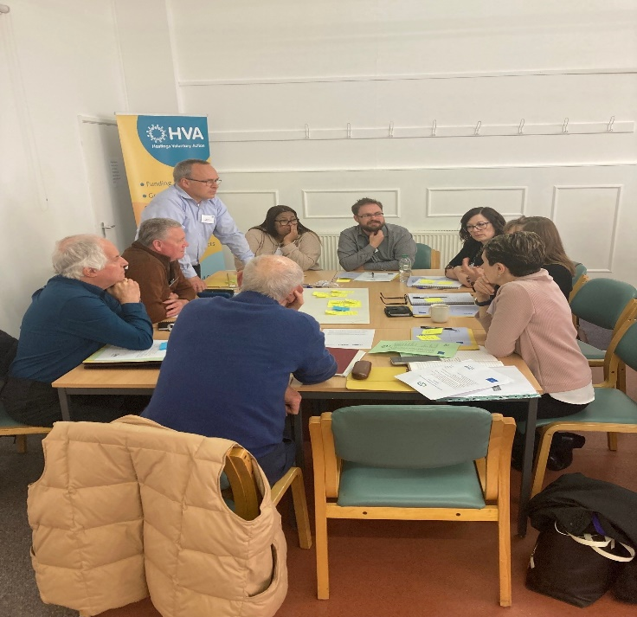

**Table 2** facilitated by Tracey Rose from Fellowship of St Nicholas, looked at the bigger picture around housing and what the longer term solutions could be.

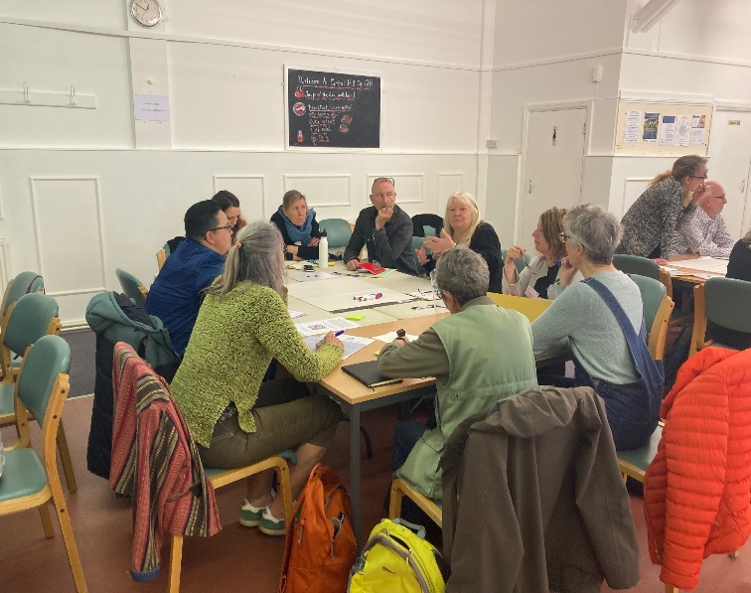

**Table 3** facilitated by Hollie Taylor from Seaview, looked at the gaps in housing services.

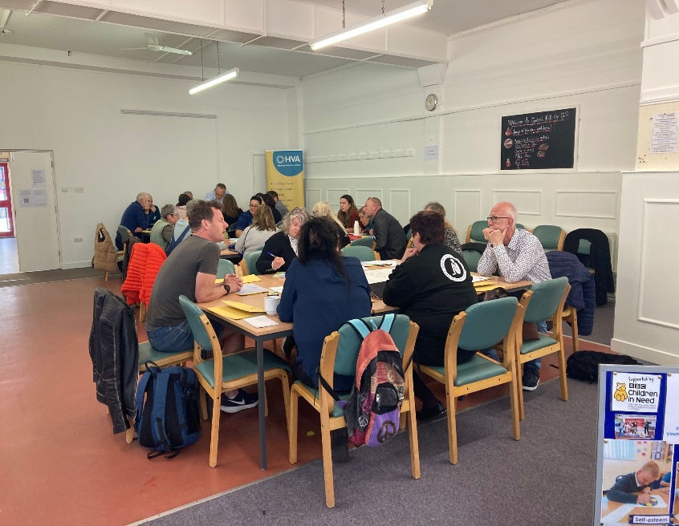

**Following the Group Exercises there was a chance for everyone to have some lunch and network**

***Meeting people in person was invaluable, made great connections.***

***Meeting others within the voluntary sector. Hearing what others are doing.***

***Meeting others who are trying to meet the same objectives.***

***A good insight into the challenges in depth. Discussions on solutions.***

**Flipchart Exercises**

Enough/sufficient mental health support

Mental Health needs

Substance misuse – connecting drug & alcohol & mental health services

Addressing adverse childhood experiences

Trauma informed approaches

Stigma

Addiction support – connect services

* Influence integrated care efforts to address mental health in drug/alcohol issues
* Early intervention/prevention

Capacity of individuals to manage input

User choice (trust)

* Mentor/friend to help people access

Capacity to cope

Do we need to start at education stage to help people cope in future life spaces

Make planning permission for AirBNB’s more difficult

Appropriate housing/supported housing

Structured housing issues – gentrification, AirBNB, Planning Policy

* Better support (including broadband, debt, health & social care etc) for people in TA
* Council (landlord) rentals – can it control market value?
* TA procurement to include clear standards (i.e. not hide behind ‘commercial’ privacy and challengeable by VCS
* Move on from TA + support
* Better specialist community housing

Housing supply for single male/females with no children – affordable

Data doesn’t reflect reality

Database for referrals in patients’ area of need? Help to know who does what

Clear/knowledgeable advice on available services

How well does signposting work? No ‘wrong door’ for informed referral

How to build and sustain trust to get over stigma

* Database

Less about gaps, more about connections/glue

Whole system approach

Society needs to change its approach & attitude

* Voice to influence LA policy, not tokenism
* Connection to LA office for individual support
* Collect evidence to influence local, regional & national policy
* Changes to Planning Policy, more social housing

Focussing of services (doubling up)

Competition for funding mitigates against collaboration

Short term funding

People on UC plus several jobs still cannot afford housing. Work isn’t paying!

* Sufficient capacity for financial advice and community development

Financial sustainability of services

Modular Housing – Grants

PRS – Challenge of minimum standards, guarantor, age of tenant

* Fair Rent Charter for Hastings
* Social Enterprise Agency
* Commitment to local tenants – Cornwall model.
* Legislation on AirBNB – close loopholes
* Housing co-operative – work to upgrade.

No rise of Housing Benefit a challenge & cannot afford rents.

Housing Associations are too large, no local interest in the same way.

Risks of creating ‘ghettos’ pricing people out.

* Short term support is good – however does not solve longer term

PRS – shrinking

Letting agency building TA as can make more money

* Single point of contact – one space for all services – Central Hall?
* Holistic space – somewhere for people to ‘be’
* Information for local Councillors on services available as part of Induction
* Green Bonds/Community Banking
* Collaboration between HBC/VCSE

People being moved out of the area away from friends – impact on mental health

* Mapping of vacant properties including over shops

**Feedback & Discussion**

**Table 1 – Mike Pepler, Citizens Advice 1066 (Facilitator)**

**Mike Pepler (CAB1066)** – On our table we looked at the issues around support services for mental health, trauma and addiction, alongside housing vulnerability. Earlier intervention is needed when people present with these issues along with a whole system approach; getting services working together. Collected data does not reflect reality in the case of services and access; people need access to all the services at the same time. Mentors can be helpful, providing knowledge and support to attend appointments in services. It would be useful to speak to landlords about the barriers they face and offer individual support.

Other issues identified were:

* Short term funding
* Lack of housing with rising demand
* Issues in temporary housing and B&B’s
* Structural issues with the Planning Policy

There is a need for community housing and support for people coming out of temporary accommodation, to help people build the capacity to manage themselves. Children need earlier intervention to stop later life dependency; they need to be taught how to run a home.

**Michelle Sterrick (FSN)** – People need support for that transition from temporary accommodation into a home. We have people coming through the door when they are at crisis point; they appreciate a safe place to come and see people as they are not allowed visitors in temporary accommodation and can often become isolated.

**Table 2 – Tracey Rose, FSN – Facilitator**

**Tracey Rose (FSN)** - On our table we looked at the bigger picture around housing and what the solutions could be longer term:

* A Rent Charter
* Tenants Commitment
* Housing co-ops
* Fair rents
* AirB&B Legislation
* Tenancy agencies
* Learning from other places (Cornwall)

People who are in housing crisis need a lot of support; money is needed for change.

**Table 3 – Hollie Taylor, Seaview – Facilitator.**

**Hollie Taylor (Seaview)** - On our table we looked at the gaps in services.

* Temporary accommodation is not always set up for transition from the street; there is no cooking facilities, fridge etc and isolation is often an issue.
* There is no skills training in temporary accommodation
* No end of tenancy support – tenancies can end without warning.
* The removal of Section 21 of the Housing Act
* Not enough houses

**Carole Dixon (EFT)** – People have no control, they can be taken from their communities, losing any good influences they may have.

**Michelle Sterrick (FSN)** – These can be ‘crunch periods’ for people, causing them more trauma. There is a lot of uncertainty in temporary accommodation. People need to help to learn how to look after themselves, pay bills etc.

**Victoria Ferguson (Optivo)** – We ran a pilot scheme working with people in temporary accommodation offering people income and employment advice before they moved into permanent accommodation. The pilot worked well, we helped people, but there was not enough money when the pilot ended to carry on the scheme. We found that some people are not in a place to accept help.

**Carole Dixon (EFT)** – We need to look at how to take pilots that work forward.

This feedback about what organisations are doing at a local level is crucial for us to be able to have influence at the local council.

**Tracey Rose (FSN)** - From this event a report will be published which we will take to a round table meeting with HBC to look at some of these solutions. This will start the process of looking at these issues. Housing is a huge problem in Hastings but we need to look at the positives and at what we need to do next to go from here. The views in the room are helpful as they are very focussed.

Carole Dixon closed the event thanking everyone for attending and their valuable input.

***The next HCN Event will be an ‘Open Mic’ (Date & Venue TBC)***

**A better understanding of the extent of the housing crisis in Hastings.**

**Learned a lot from the chat in groups, great to see ideas coming together.**

**Good to meet with new people. The community of Hastings getting together.**

**Good to meet others in the same industry. Gained a lot of information. Good to look at gaps.**