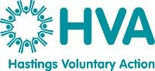

**Hastings Food Network Action Plan**

Hastings Food Network is a partnership of local groups and organisations working with food in a variety of ways.

We believe that food is key to helping our community to thrive. No one in our town should have to go without food or buy poor-quality food which does not nourish them. Lack of access to good food has far-reaching consequences, from poorer educational outcomes to poor mental health. The types of food we eat and how we produce it are significant drivers of the climate crisis. This also contributes to making our residents vulnerable to uncertainty in international supply chains, especially those on low incomes.

This action plan recognises the importance of encouraging more sustainable and resilient eating habits whilst also acknowledging the role that food plays in bringing communities together and the importance of the food economy in creating a food-secure town. It also sees food as a key aspect of broader wellbeing.

Whilst the vision of a town where no one goes hungry is simple, achieving this is more complicated. This action plan focuses on what partners can do together to address food insecurity in Hastings. We see our network’s role as first and foremost an infrastructure mechanism for food security but also a campaigner, a promoter and a system lead advocate to support broader structural change – encouraging teams across the Borough and County Council’s and beyond to work towards this vision.

This action plan is a working document with regular updates and amendments being made yearly as we review progress to date and reflect on our priority areas. We will work towards our food actions using the key priorities as identified by Hastings Food Network partners.

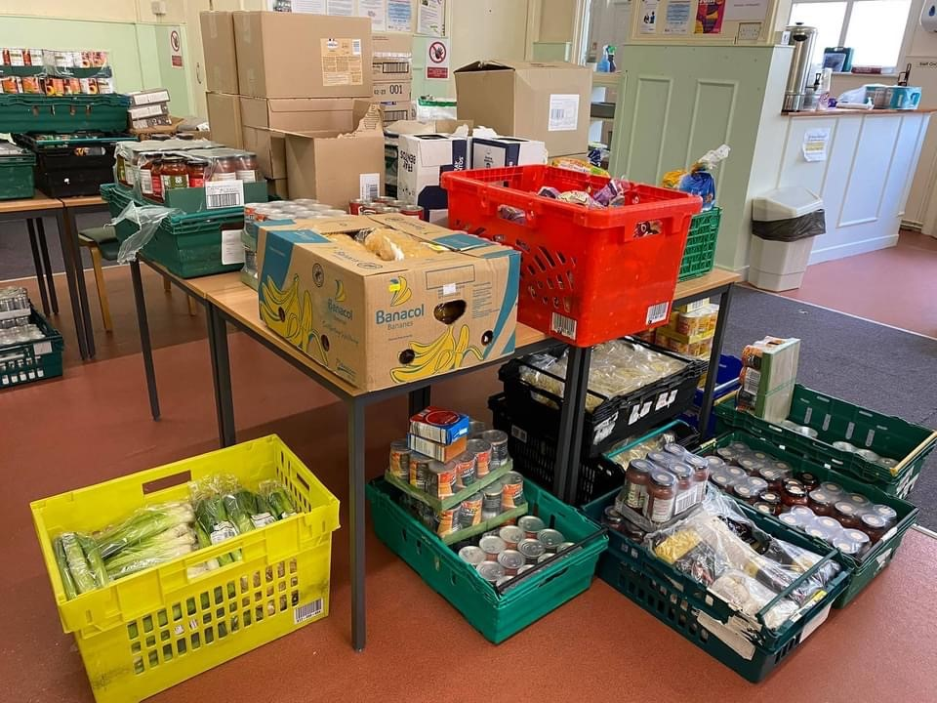

**Priority one – Create a food movement in Hastings that connects and collaborates effectively**

|  |  |  |  |  |
| --- | --- | --- | --- | --- |
| Action | Work to date | Responsibility | Timescale | Notes |
| **Funding of network co-ordinator**  **Establish a broad, diverse and dynamic local food network with good governance and strategy**  .  **Facilitate shared learning opportunities, themed meetings and events on a range of food related issues.**  **Work in partnership with wider stakeholders and organisations.** | Role funded by Public Health til March 2026  Terms of reference created.  Local food action plan developed and launched.  Network ‘brand’ and social media channels created.  Programme of network meetings established.  Public Health Healthy Weight Partnership and Good Food East Sussex, Feeding Britain, Trussell participation Group . | Public Health.  Network partners.  HVA project lead  Network partners and project lead | Review March 2026.  Complete.  Launch April 2025.  Ongoing  Ongoing  Ongoing | Action plan to be embedded in HCN Poverty Strategy.  Various meeting formats have been trialled to suit partners, capacity to attend meetings is a challenge. Less meetings but themed ones was the preference for 2025. Small working groups to be formed for relevant projects.  October Good Food East Sussex food events across Hastings and St Leonards. Provide regular updates to the GFES newsletter hosted by Public Health. Participate in Trussell Participation Group and attend Feeding Britain working groups, peer support meeting and webinars. |

**Priority two – Work towards achieving long term food security in Hastings**

|  |  |  |  |  |
| --- | --- | --- | --- | --- |
| Action | Work to date | Responsibility | Timescale | Notes |
| **Promote access to dignified emergency food support.**  **Provide and information training to community stakeholders on food poverty referral pathways and emergency food access when needed.**  **Work with local and national partners to embed a range of advice and support provision in to local community food projects.**  **Provide infrastructure support to local food projects through project consultation, volunteer recruitment and funding opportunities.**  **Encourage systems thinking around the connections between food and health inequalities**  **Promote food as a tool in enabling health conversations, in reducing loneliness and isolation and in building social connections.** | Hastings Food Access sheet  Joined Dignified Food Alliance, workshop held in Hastings in Nov 2024.  Hastings 2024 Winter Readiness event  Development of the social supermarket model throughout Hastings. Alongside Feeding Britain’s Pathways from Poverty programme.  Consultation with Broomgrove prior to the launch of their social supermarket.  Farley Bank – need identified and pilot set up actioned  Themed Food and Health Inequalities Meeting with ICB Lead  Learning from the Hastings social prescribing pilot with NASP.  Partnership with the Hastings Ageing Network partners to support the running of community lunch clubs.  Partnership working with ESCC Tackling Loneliness project on cultural food events. | Network partners  Project lead  Network partners/project lead  Oasis Project Broomgrove, ETC Sussex, HBC, Southern Housing, Network partners and project lead  Network partners, Feeding Britain, Public Health, project lead.  Warming up the Homeless  ICB Sussex  HVA/Ageing Network partners  East Sussex College, project lead, HBC Age Friendly Champion.  Project lead, ESCC, Ageing Network Cultural Involvement Group | Ongoing -  Nov 2024  Autumn/Winter  Ongoing  Broomgrove social supermarket launched Spring 2024  Farley Bank pilot Winter 2024.  April 2025  Ongoing  Ongoing  Ongoing | Updated annually. Add visual map    Currently working with Feeding Britain, HBC and network working group on longer term plans for Farley Bank and the surrounding areas.  Commitment to explore this theme further. Oct 2025 event in Priory Meadow?  Eat Well, Age well older peoples food resilience initiative April 2025 |

**Priority 3 – Work towards achieving healthy food provision for all**

|  |  |  |  |  |
| --- | --- | --- | --- | --- |
| Action | Work to date | Responsibility | Timescale | Notes |
| **Promote the importance of healthy food for all.**  **Support local ‘healthy eating’ events and activities.** | Share Government led healthy eating campaigns such as 5 a day, Sugar Smart etc through comms channels and community food projects.  Promote local farmers markets, veg box schemes etc.  Work with Creative Concoctions on social prescribing initiative for older people including nutrition advice.  Influence and feed in to the Hastings Local Plan and Corporate Plan where appropriate.  Promote HAF activities in Hastings.  Identify opportunities through network meetings. | Network partners, Public Health, project lead.    Creative Concoctions, project Lead  HBC, project lead, Public Health, PCN/ICB  HVA, HBC, Public Health  Project lead | Ongoing through comms  Ongoing  April 2025  Ongoing  Ongoing  Ongoing | Need to identify options to work in partnership on this. Explore options to embed more fresh produce in to community food projects |

**Priority 4 – Look at food security from a climate perspective**

|  |  |  |  |  |
| --- | --- | --- | --- | --- |
| Action | Work to date | Responsibility | Timescale | Notes |
| **Provide opportunities for training and education around climate and food issues such as reducing food waste, growing food, recycling packaging etc.**  **Promote campaigns to produce a shift to more sustainable food including fresh, unprocessed, seasonal, local, organic, Fairtrade etc.**  **Promote local authority food waste collection schemes and composting schemes.**    **Encourage collection and redistribution of consumable surplus food to local organisations feeding people in need.**  **Promote food growing by working with local community projects.** | Work with Community Energy South to deliver Climate literacy training in Hastings.  HBC Plastic free motion approved by Cabinet  Support local organisation to set up composting scheme.  Food Waste collection schemes in Local Authorities becomes a legal requirement.  Promotion of schemes like Neighbourly, Fareshare etc being used in Hastings social supermarkets etc  Participation in food supplies working groups with Feeding Britain.  Working towards a Green Social Prescribing themed meeting. | Project lead  HBC, Public Health/ project lead  Hastings Composting Scheme, project lead  HBC  Network partners  Transition Town Hastings, Green Social Prescribing project, network partners, project lead. | Feb 2025  Jan 2025  Funding and advice given 2022.  2026  Ongoing  Summer 2025 | HBC have a Climate Strategy and working in partnership with the Hastings Food Network is cited in this document. |

**Priority 5 – Campaign for better food education in Hastings**

|  |  |  |  |  |
| --- | --- | --- | --- | --- |
| Action | Work to date | Responsibility | Timescale | Notes |
| **Promote food education in the community both in schools and through adult learning as a key component of long term food resilience.**    **Promote and enable local food education opportunities and map provision.** | Participated in ESCC Skills and Education Forum – discussion re skills shortages in Hospitality and Catering workforce in Hastings.  Facilitated a themed meeting on Food Education in Hastings.  Identified need for more community chefs/cookery leaders.  Explore opportunities within NHS/ICB/PCN to progress this further.  Campaign with Feeding Britain for a review of food education in the National Curriculum.    Work with Hastings food education providers to enable free and chargeable workshops, demos and courses across Hastings for people of all ages. | Project lead  East Sussex food partnerships, Public Health  ESCC College Group, food network partners, HAF providers | Spring 2024  Summer 2024  Ongoing discussions  April 2025  Ongoing |  |

For further details about the work of the Hastings Food Network please go to -

<https://hastingsvoluntaryaction.org.uk/project/hastings-food-network>

<https://www.facebook.com/hastingsandstleonardsfoodnetwork>

Or via email to [debby@hastingsvoluntaryaction.org.uk](mailto:debby@hastingsvoluntaryaction.org.uk)