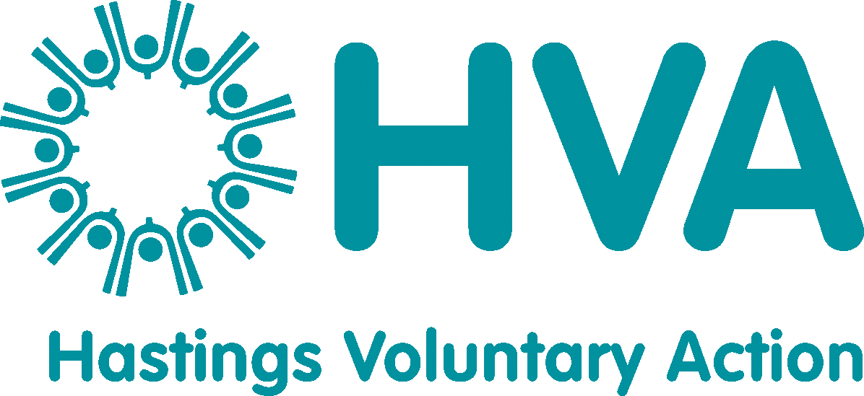

Age Friendly Communities
Spring 2025 Newsletter

Hello All
Welcome to the latest edition of our newsletter – an Age Friendly guide to what’s happening, where and when.

Thurs 10th April 10.30-12 Central Hall Spring Gathering
Join us for coffee, cake and chat plus information on other age-related activities and sessions taking place across Hastings in the coming months.

Tues 22nd April 10.30-12 Central Hall Healthwatch Listening Tour
The Healthwatch East Sussex Listening Tour focuses on different areas of East Sussex, to hear from local people about their experiences of health and care services in the area, and what could be done to improve things. Findings are then shared with local services, including the NHS and council, and highlight what needs to be done to make services better. Healthwatch work with services to make sure that people’s views are listened to and acted upon.
Do take this opportunity to come and talk to the team and whilst you’re there do support Chef John who will be serving tasty snacks from the Central Hall café at reasonable prices!

Tues 6th May 10.30-12 Central Hall Unity in the Community

Join us for another of our hugely successful diverse coffee mornings where we encourage people as they age from a mix of cultural backgrounds to come together and create a sense of unity in the community.

Mon 12th May 12 midday Community Lunch at Coast Restaurant- see attached flyer *

Tues 20th May 10.30-12 Central Hall Brain health

As part of Dementia Action week we will be joined by Alzheimers Research for an interactive session on brain health. One not to miss!

Mon 2nd June 12 midday Community Lunch at Coast Restaurant – see attached flyer *

Fri 13th June Celebration of Ageing afternoon tea 2-4pm Coast Restaurant

To mark the national campaign Age Without Limits www.agewithoutlimits are pleased to be holding an afternoon tea in partnership with the East Sussex College Group to include a mocktail, sandwiches and cake at £10 per head. To book call Coast on 030 300 38456

We do have a discretionary fund for anyone who may like to attend but is unable to meet the cost – please contact me for further details debby@hastingsvoluntaryaction.org.uk

Thurs 19th June 10.30-12 Central Hall East Sussex Hard of Hearing

If you have questions about hearing assistive equipment, hearing aid checks, lip reading lessons or would like a free ear wax health check then come and talk to the team at East Sussex Hearing for advice on anything hearing related.

Thurs 17th June 11-1 Cuppa Club Priory Meadow shopping centre

Free tea, coffee, cakes, information and entertainment in the large area outside M@S – bring friends or come and make new ones!

Thursdays 5.15 Garden Room St Michael’s Hospice Community Choir t: Free for the first term (future sessions likely £4 each)
The Hospice are thrilled to launch a new Community Choir in partnership with The Music Well, led by choir director Kerry Evenden. This is a wonderful opportunity to connect through music, meet new people, and experience the joy of singing. The choir is open to everyone, whether you’re a patient, carer, bereaved, staff, volunteer, or member of the local community. For more information or to sign up, contact Martin Symons at commvolunteering@stmichaelshospice.com or 01424 445177 x273.

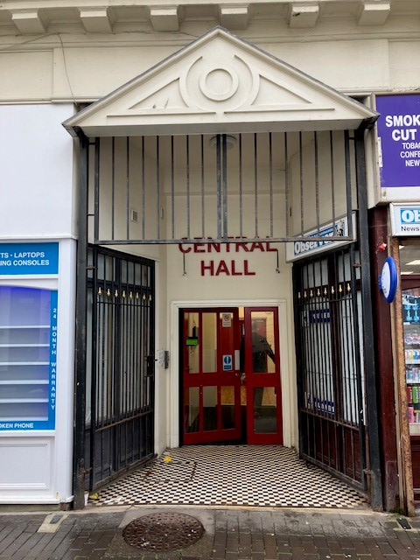

Central Hall has full disabled access. For further info on any of the above contact either debby@hastingsvoluntaryaction.org.uk 07513 234 307, or jane@hastingsvoluntaryaction.org.uk

