Hastings Borough Council (HBC) Hastings Housing Strategy Workshop
Central Hall, Hastings
1st August 2025

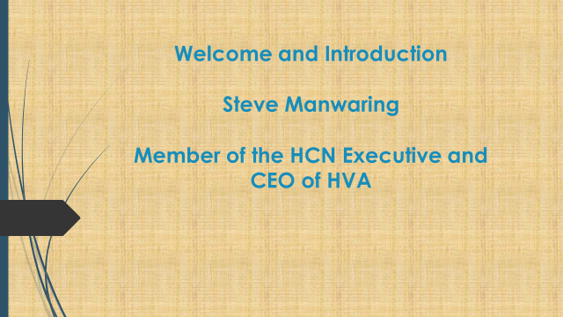

Steve Manwaring opened the event, speaking about the functions of the HCN Executive (HCNE) Group:
To represent
To engage
To highlight and respond
To celebrate and promote

And how the HCNE engages with the community:
Six events per year
2 x themed events, 2 x open mic events, 1 joint HBC/HCN consultation event
All themed event topics chosen by membership using the ‘Hot Topics’ list
Brief pre-meeting before LSP if needed

Steve then introduced Alan Sheppard, the Housing Strategy and Operations Manager at Hastings Borough Council (HBC) who gave a presentation about the draft Housing Strategy:

The Five Priorities
Deliver the homes we need
Prevent homelessness and end rough sleeping
Create a rented sector which works for tenants and landlords
Homes that support health, independence, and longer lives
Reduce carbon emissions from housing and future-proof homes for a changing climate.

Mary Carter (HCNE) explained the interactive table activity with all attendees which asked them to use flip charts to record their views about the draft Housing Strategy

ATTENDEES
First Name | Last Name | Organisation
Grace |  | Rebellion Housing
Lesley | Adaur | Mediation Plus
Teresa | Andrews | HARC
Penny | Beale | HHSS Group
Tricia | Burman
Jane | Caley | HVA
Mary | Carter | HVA/HCN
Michael | Courts | ESCC
Jane | Dye | FSN
Jodie | Goffee | Freedom Living Housing Co-operative
Mark | Goffee | Freedom Living Housing Co-operative
Graham | Hodgson | Care For the Carers (CFTC)
Kim | Kelly | HVA
Elise | Liversedge | Hastings Older Women Co Housing HOWCH
Steve | Manwaring | HVA
Gill | Reynolds | Sussex Community Development Association
Alan | Sheppard | HBC
Following the Table Activity, Michael Courts, Vice-Chair of Housing Strategy Steering Group (ESCC) took a feedback and Q&A session

Deliver the Homes We Need
- Homes with services and infrastructures
- Don’t need luxury, over-priced, badly built private flats
- Shared ownership is not affordable
- Planning permission should insist on genuinely affordable
- The Air B&B’s percentage of housing stock must be limited to a fair percentage
- Local government needs to be given the power to limit the number of planning applications
- Kit homes

Prevent Homelessness and End Rough Sleeping
- Homelessness prevention – learn from the Eastbourne Hub
- How will it be funded – will co-production and multi-agency partnerships be sufficiently funded? Include backfill etc for attendance, governance & leadership structures
- Neighbourhood level awareness workshops and dialogue to support refugees and migrants
- Prevent revolving door
- Funding – strategic leverage. Can’t rely on Trusts/Foundations to operate on a strategic level this longer term work requires
- Special support needs aligned with housing provision
- Pay heed to community tensions (especially new/refurbished accommodation, if better standard than settled social housing
- Address longer term impacts of long stays in temporary accommodation (TA) on physical/mental health, educational attainment, work prospects (when settled and when in TA)
- Prevention focus – financial to prevent eviction and address needs before home is lost.
- Local procurement
- Protecting the strategy through Devolution
- Where conflict is a factor in homelessness risk – provide access to mediation services, early intervention

Create a Rented Sector Which Works for Tenants and Landlords
- Affordability not keeping pace with income and now a two tier system
- Rent capping should be explored
- Short supply increasing rents
- Air B&B’s models elsewhere should be examined
- Homes not hotels
- Housing needs to be locally affordable
- Deposits and guarantees an issue (Bond Board)
- Anti-social behaviour or conflict – need for mediation
- Reform AST as the default tenure
- More support to co-ops, Hastings Commons; what can be learnt from this?
- Carers need to stop working. They face particular challenges
- How can people with long term health conditions keep their homes
- Kit homes and self builds
- More pressure to use vacant land to build on
- Make affordability linked to local wages and incomes
- Second homes taxed and money ring fenced for housing delivery
- Planning system needs to genuinely enable affordable housing and not let this be diluted
- Poor conditions; damp, guttering, condensation, difficult to heat
- Seaview developing HMO: look at this as a wider model
- Absence of ‘move on’ accommodation
- Temporary accommodation leading to isolation and limited opportunity to lead a normal life
- Proper approach to fuel poverty and energy

Homes that Support Health, Independence and Longer Lives
- Housing Associations (HA’s) – responsibility to promote social health
- HA residents to get more support to: meet and connect with each other, link in with local community activities and groups e.g. warm welcome space
- HA’s have spaces that are under used
- Support people to live independently in their own homes as long as possible to prevent them going into care homes
- Environment around homes is important, links to community safety & substance dependency, cleanliness
- Need long term security for tenants
- Improved understanding of loneliness and how it impacts health; Housing Strategy to link with ASC prevention work
- Create more community/living spaces
- Houses need to be in good repair e.g. insulated and with no mould/damp
- Street safety
- What assets are already out there? Housing/landscape
- Occupational Health to help people stay in their homes longer – should be a default
- Mediation support for neighbourhood conflict/ASB and in retirement schemes etc

Reduce Carbon Emissions from Housing and Futureproof Homes for a Changing Climate
- Car sharing schemes as part of housing development
- Housing based community transport (electric) for hospital visits etc
- Green roofs
- Solar/heat pumps need to be more affordable
- Incentivise the use of public transport away from car ownership
- More grants; profit over climate
- Stringent requirements on developers; climate over profit
- How does this fit with Conservation Zones
- Examples of quick wins you can easily implement
- Sharing financial incentives/realities/impacts of changes
- Water butts
- Budget and staff to maintain communal green spaces
- Heat loss drone surveys to highlight homes that have inadequate insulation
- Incentivise using car free electric/hybrid. Cycling
- Laws and strategy need to be enforced. Developers can’t move goalposts after getting contracts
- Best practice elsewhere (Europe)
- Need to be pollinator friendly
- Opportunity to bring together communities to share vision for climate concerns
- Climate change bus tours

